SIMATS ENGINEERING
ASSESSMENT TOOL 1
COURSE NAME: INTERNET PROGRAMMING
COURSE CODE: CSA4302
QUESTIONS: Total Marks: 30

Code of Conduct:
I SANJAI S(192511018) certify that this submission is my original work
and that I have adhered to the guidelines specified for this assessment. I understand that any
violation of academic integrity rules will result in disciplinary action.

SIGNATURE OF THE STUDENT: SANJAI S

EXPERIMENT 1: RESPONSIVE LAYOUT DESIGN
(a) Analysis of the Lack of Responsiveness in the Existing Layout
The misalignment and improper spacing on mobile and tablet devices in the existing retail website are likely caused by outdated, non-responsive web design practices:
- Fixed Dimensions: Using exact pixel values (e.g., width: 1200px; or height: 800px;) instead of relative units (like %, vw, or vh). This forces smaller screens to scroll horizontally, breaking the layout.

- Missing Viewport Meta Tag: Without <meta name="viewport" content="width=device-width, initial-scale=1.0">, mobile browsers attempt to render the desktop width and scale it down artificially, rendering text illegible.

B C D
RESPONSIVE WEBPAGE LAYOUT CODE IMPLEMENTATION
HTML
<!DOCTYPE html>
<html lang="en">
<head>
<meta charset="UTF-8">
<meta name="viewport" content="width=device-width, initial-scale=1.0">
<title>Responsive Retail Layout</title>
<style>
/* Base Reset & Variables (d: Spacing and Visual Consistency) */
:root {
--primary-color: #2c3e50;
--secondary-color: #ecf0f1;
--text-color: #333;
--spacing-sm: 0.5rem;
--spacing-md: 1rem;
--spacing-lg: 1.5rem;
}
*, *::before, *::after {
box-sizing: border-box;
margin: 0;
padding: 0;
}

body {
font-family: system-ui, -apple-system, sans-serif;
color: var(--text-color);
background-color: #f9f9f9;
}

/* (b) Mobile-First Layout Setup Using CSS Grid */
.layout-container {
display: grid;
grid-template-areas:
"header"
"nav"
"content"
"footer";
grid-template-columns: 1fr; /* 100% width on mobile */
min-height: 100vh;
}

/* Structural Components Assignment */
header { grid-area: header; background: var(--primary-color); color: white; padding: var(--spacing-lg); text-align: center; }
nav { grid-area: nav; background: var(--secondary-color); padding: var(--spacing-md); }
main { grid-area: content; padding: var(--spacing-lg); background: white; }
footer { grid-area: footer; background: var(--primary-color); color: white; padding: var(--spacing-md); text-align: center; }

/* (d) Flexbox for Navigation Links Distribution */
.nav-links {
display: flex;
flex-direction: column; /* Stacked vertically for mobile */
gap: var(--spacing-sm); /* Consistent spacing without margin collapse */
list-style-type: none;
}

.nav-links a {
display: block;
padding: 0.8rem;
text-decoration: none;
color: var(--primary-color);
font-weight: bold;
background-color: white;
border-radius: 4px;
text-align: center;
transition: background-color 0.3s ease;
}

.nav-links a:hover {
background-color: #bdc3c7;
}

/* (c) Media Queries for Tablet (>= 768px) */
@media (min-width: 768px) {
.layout-container {
grid-template-areas:
"header header"
"nav content"
"footer footer";
grid-template-columns: 220px 1fr; /* Nav becomes a 220px sidebar */
}

.nav-links {
text-align: left; /* Align text naturally in sidebar */
}
}

/* (c) Media Queries for Desktop (>= 1024px) */
@media (min-width: 1024px) {
.layout-container {
grid-template-columns: 250px 1fr; /* Expand sidebar slightly */
max-width: 1400px; /* Cap max width on ultra-wide screens */
margin: 0 auto; /* Center the whole layout */
box-shadow: 0 0 15px rgba(0,0,0,0.1);
}

main {
padding: calc(var(--spacing-lg) * 2); /* Increase breathing room */
}
}
</style>
</head>
<body>
<div class="layout-container">
<header>
<h1>Responsive Retail Store</h1>
</header>

<nav>
<ul class="nav-links">
<li><a href="#">Home</a></li>
<li><a href="#">New Arrivals</a></li>
<li><a href="#">Categories</a></li>
<li><a href="#">Contact Us</a></li>
</ul>
</nav>

<main>
<h2>Welcome to Our Store</h2>
<p style="margin-top: 1rem; line-height: 1.6;">
Notice how this layout adapts. On mobile, elements stack vertically to preserve readability. On a tablet, the navigation shifts to a left-aligned sidebar. On a desktop, the sidebar widens, padding increases, and the layout centers itself to prevent stretching too far on ultra-wide monitors.
</p>
</main>

<footer>
<p>&copy; 2026 Responsive Retail Store</p>
</footer>
</div>
</body>
</html>

(E) EVALUATION OF THE RESPONSIVE DESIGN AND SUGGESTED IMPROVEMENTS
Evaluation: The implemented design effectively solves the lack of responsiveness through a structural CSS Grid. By explicitly defining grid-template-areas inside media queries, the layout fundamentally reshapes itself without duplicating HTML elements.

- Fluid Typography: Instead of relying entirely on media queries to change text size, implement CSS clamp() (e.g., font-size: clamp(1rem, 2vw, 1.5rem);). This allows fonts to smoothly scale based on the viewport width rather than "jumping" at specific breakpoints.

- Container Queries: For inner components (like product cards inside the <main> area), use CSS @container queries instead of viewport media queries. This ensures product cards rearrange themselves based on the available space inside the content area rather than the overall screen size, making the components more reusable.

- Accessibility (a11y): Add aria-label="Main Navigation" to the <nav> tag and ensure a visible focus state (:focus-visible) for the links to support keyboard and screen reader users navigating the responsive layout.

OUTPUT:
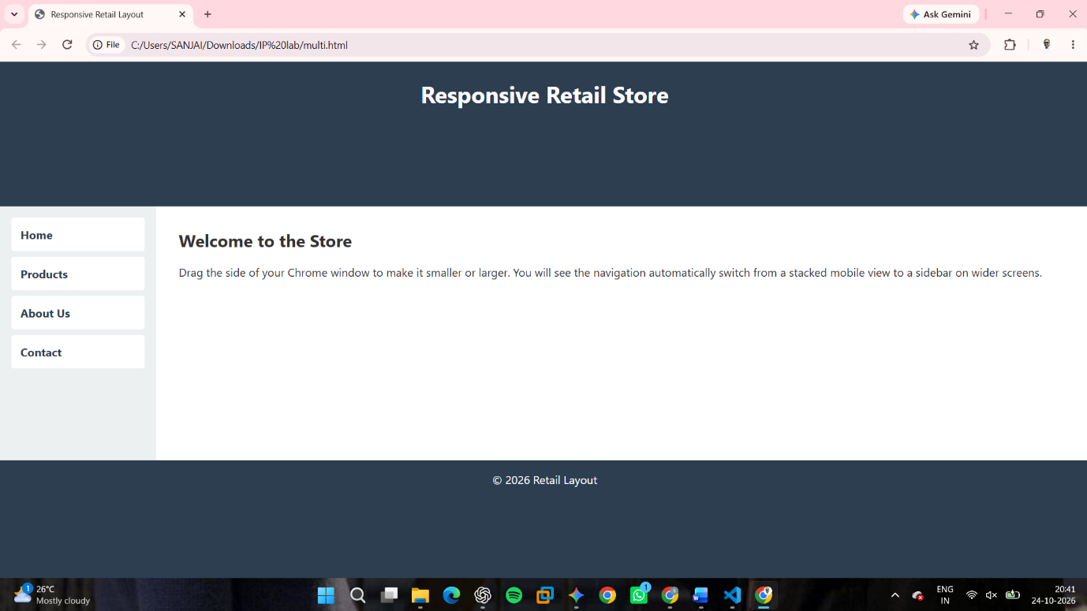

EXPERIMENT 2: FORM VALIDATION USING JAVASCRIPT
(a) Analysis of Existing Form Validation Issues The registration form fails because it relies on basic or backend-only validation. This causes page reloads for errors, frustrating users. Lacking HTML5 input types (like type="email") ignores native browser checks, and the absence of JavaScript Regular Expressions allows structurally invalid data (e.g., missing top-level domains or letters in phone numbers) to bypass the system.

B C D IMPLEMENTATION
HTML
<!DOCTYPE html>
<html lang="en">
<head>
<meta charset="UTF-8">
<meta name="viewport" content="width=device-width, initial-scale=1.0">
<title>Form Validation</title>
<style>
body { font-family: sans-serif; padding: 2rem; background: #f4f4f4; }
.form-group { margin-bottom: 1.2rem; max-width: 300px; }
input { width: 100%; padding: 8px; border: 2px solid #ccc; border-radius: 4px; }
input.invalid { border-color: #d93025; }
input.valid { border-color: #188038; }
.error-msg { color: #d93025; font-size: 0.85rem; display: none; margin-top: 4px; }
button { padding: 10px 15px; background: #2c3e50; color: white; border: none; cursor: pointer; }
</style>
</head>
<body>

<h2>Registration Form</h2>
<form id="regForm">
<!-- (b) Input fields with appropriate HTML attributes -->
<div class="form-group">
<label>Email:</label>
<input type="email" id="email" required placeholder="name@example.com">
<div id="emailError" class="error-msg">Invalid email format.</div>
</div>

<div class="form-group">
<label>Phone Number:</label>
<input type="tel" id="phone" required placeholder="10-digit number" maxlength="10">
<div id="phoneError" class="error-msg">Must be exactly 10 digits.</div>
</div>

<button type="submit">Submit</button>
</form>

<script>
// (c) Regular Expressions
const emailRegex = /^[^\s@]+@[^\s@]+\.[^\s@]+$/;
const phoneRegex = /^\d{10}$/;

const email = document.getElementById('email');
const phone = document.getElementById('phone');
const form = document.getElementById('regForm');

// (d) Real-time validation logic
function validate(input, regex, errorId) {
const errorMsg = document.getElementById(errorId);
if (regex.test(input.value.trim())) {
input.className = 'valid';
errorMsg.style.display = 'none';
return true;
} else {
input.className = 'invalid';
errorMsg.style.display = 'block';
return false;
}
}

// Trigger validation on input (real-time)
email.addEventListener('input', () => validate(email, emailRegex, 'emailError'));
phone.addEventListener('input', () => validate(phone, phoneRegex, 'phoneError'));

// Prevent submission if invalid
form.addEventListener('submit', (e) => {
const eValid = validate(email, emailRegex, 'emailError');
const pValid = validate(phone, phoneRegex, 'phoneError');
if (!eValid || !pValid) e.preventDefault();
});
</script>
</body>
</html>

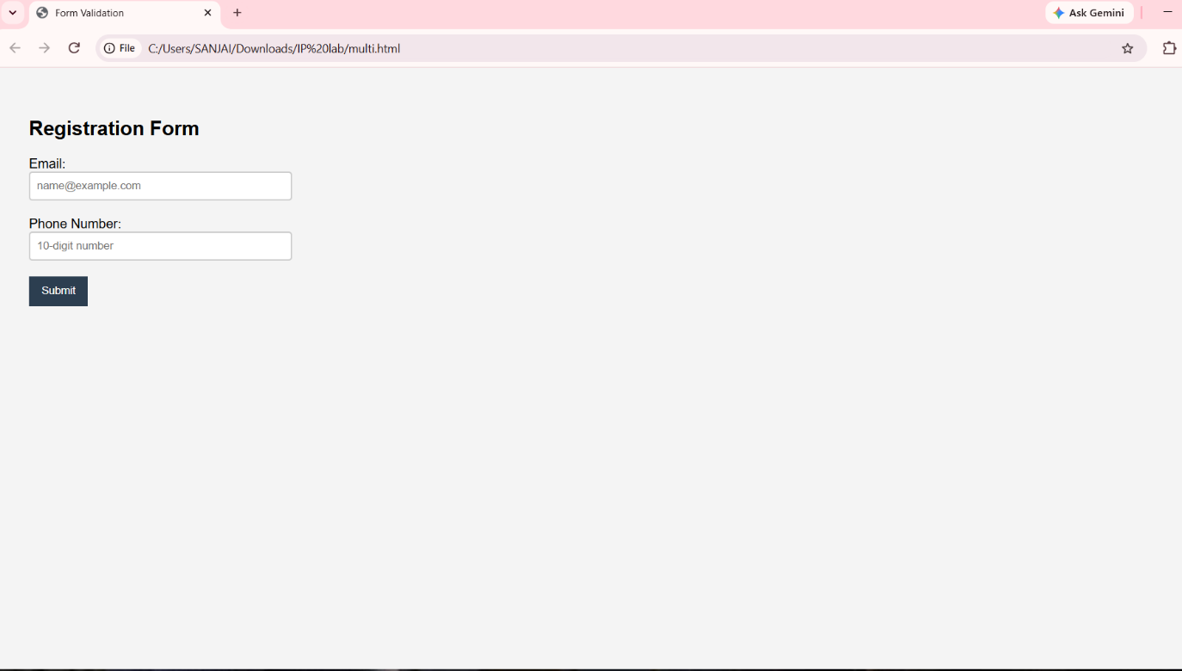
OUTPUT:
EXPERIMENT 3: CSS LAYOUT DEBUGGING
(a) Analysis of Layout Overlapping Issues Webpage layouts typically overlap during resizing due to the misuse of position: absolute; combined with fixed dimensions (e.g., width: 800px;, height: 400px;). Absolute positioning removes an element from the normal document flow. When the browser window shrinks, surrounding static content reflows, but absolute elements remain fixed to their coordinates, causing collisions and overlapping.
(b) The Role of the CSS Box Model The CSS Box Model dictates how a web element's total size is calculated (Content + Padding + Border + Margin). By default (box-sizing: content-box), if a container is 100% wide and you add 20px of padding, the actual width becomes 100% + 40px, pushing it off-screen and breaking the layout. Changing this to box-sizing: border-box forces the browser to include padding and borders inside the defined width, maintaining layout stability during resizing.

B C D
debugging and Modifying the CSS To fix the overlapping issue, we replace rigid absolute positioning and fixed heights with CSS Flexbox and relative scaling.
HTML
<!DOCTYPE html>
<html lang="en">
<head>
<meta charset="UTF-8">
<meta name="viewport" content="width=device-width, initial-scale=1.0">
<title>CSS Layout Debugging</title>
<style>
/* (b) CSS Box Model Fix: Apply border-box globally */
*, *::before, *::after {
box-sizing: border-box;
margin: 0;
padding: 0;
}

body { font-family: sans-serif; background-color: #e9ecef; }

/* (c) Positioning Techniques: Use Flexbox instead of Absolute Positioning */
.container {
display: flex;
flex-wrap: wrap; /* Allows natural stacking on small screens */
gap: 1rem; /* Replaces complex margin calculations */
padding: 1rem;
min-height: 100vh; /* Replaces fixed heights */
}

/* (d) Proper Alignment: Elements adapt gracefully */
.sidebar {
flex: 1 1 250px; /* Grow, shrink, and base width of 250px */
background: #34495e;
color: white;
padding: 1.5rem;
border-radius: 8px;
}
.main-content {
flex: 3 1 400px; /* Takes remaining space, wraps if < 400px is available */
background: white;
padding: 1.5rem;
border-radius: 8px;
box-shadow: 0 4px 6px rgba(0,0,0,0.1);
}
</style>
</head>
<body>
<div class="container">
<div class="sidebar">
<h2>Sidebar</h2>
<p>This element previously overlapped because of absolute positioning. Now it uses Flexbox to share space.</p>
</div>
<div class="main-content">
<h2>Main Content Area</h2>
<p>Resize the browser window. Instead of overlapping, the flex items will automatically adjust their widths. If the screen becomes too narrow, the <code>flex-wrap: wrap</code> property ensures the main content gracefully drops below the sidebar, maintaining perfect usability.</p>
</div>
</div>
</body>
</html>
(E) EVALUATION AND BEST PRACTICES
Evaluation: The modified layout successfully eliminates overlapping. By using display: flex and flex-wrap: wrap, the elements are kept in the document flow. They respond dynamically to the viewport size, shrinking proportionally and stacking vertically when horizontal space runs out.

OUTPUT:
